MAST 382 Fall 2020
Exam 4

Instructions: The exam has two parts. Part I refers to questions related to Lectures 20 (Human Impacts) and 21 (Climate Change). Part II refers to Lectures 17 (Foundation of Life-Chapter 12), 18 (Marine Ecology-Chapter 14), 19 (Marine Ecosystems-Chapter 15) and external sources. Please note that the video that you are asked to watch in Part II Question 4 is about 1 hour long, budget your time accordingly.

Answer all questions. Upload the completed exam as a word document into Canvas saved as “Last name_exam 1”. We will not accept hand-written answers unless noted otherwise in the instructions to each question. The exam is due on 12/09/20 at 5 pm.

Part I: Questions related to Lectures 20 (Human Impacts) and 21 (Climate Change)

1. (5 pts) Please explain six ocean-related missions that fall under EPA's mandate to enforce the Clean Water Act of 1972 and its amendments in 1977 and 1987
The missions are
• systemic solutions for the prevention, reduction, mitigation and removal of marine pollution including plastics
• transition to a circular and blue economy
• adaption to and mitigation of pollution and climate change in the ocean
• sustainable use and management of ocean resources
• development of new materials including biodegradable plastic substitutes, new feed and food
• urban, coastal and maritime spatial planning

2. (5 pts) State your home state or the state you were born. For this specific state, investigate the following using data from an U.S. Environmental Protection Agency (EPA) website that we used and accessed in class:

2.1 How many pounds (lbs.) of pollutants are managed/regulated by the EPA that are released (a) into the water and (b) into the air. Which chemical contributes the most in each category?
100 billion lbs of pollutants are released into the water and 200 billion lbs of pollutants are released into the air in Ohio state.
2.2 If you distribute the managed pollutant load equally over the entire population of your state, what is the per person contribution in your state (lbs. per person)?
This will result into 20lbs of pollutants per person.

2.3 Under what legal authority does the EPA collect and distributes these data?
Under the universal environmental protection authorit .
3. (5 pts) If we assume that the apparent linear trend of decreasing US emissions of CO₂ per capita per year between 2008 and 2017 continues, how many years into the future will it take for us in the US to reach the per capita emissions of the European Union at 7 ton CO₂ per capita per year in 2017? [Hint: Muntean et al., 2018: Fossil CO2 emissions of all world countries - 2018 Report, European Union, doi:10.2760/30158 and graphs therein that we discussed in-class.]

It would take 20 years for US to reach the per capita emissions of the European Union at & ton per capita year.
4. (5 pts) A Newark, DE "University Farm" meteorological station is included in global data bases to estimate global and regional climate change. What is the warming (in degrees Celsius per century) for this station and how does it compare to regional, national, and global expectations? Note that the records at
The warming is at 2.78 degree Celsius per century, this rate compares to the regional in that the regional is a bit lower and it is higher than the national and global expectations.

http://berkeleyearth.org/data-new

[Hint: You may want to search for "Individual Station Data" rather than gridded averages.]

5. (5 pts) Please read the Op-Ed "The conversion of a Climate Change Skeptic," at
https://www.nytimes.com/2012/07/30/opinion/the-conversion-of-a-climate-change-skeptic.html
that appeared in the New York Times in 2012. Try to answer the following questions

5.1 What did Prof. Mueller do to change his mind about climate change?
Prof. Mueller carefully analyzed the report Berkeley Earth Surface Temperature project and their results show that the average temperature of the earth’s land has risen by two and a half degrees Fahrenheit over the past 250 years, including an increase of one and a half degrees over the most recent 50 years. Moreover, it appears likely that essentially all of this increase results from the human emission of greenhouse gases.
5.2 What errors are contained within air temperature data used to estimate a global average?
The errors are the inclusion of solar activity as a factor that increases the global temperatures yet solar activity only increases the brightness of the su.
5.3 How does his conclusion differ from that of the International Panel of Climate Change?
His conclusion defers from that of the International Panel of Climate Change in that while I.P.C.C. concluded only that most of the warming of the prior 50 years could be attributed to humans. It was possible, according to the I.P.C.C. consensus statement, that the warming before 1956 could be because of changes in solar activity, and that even a substantial part of the more recent warming could be natural. He rather concluded that the global warming was caused by the rise in the amount of carbon dioxide in the atmosphere.
5.4 How important are effects due to solar cycles, volcanos, and ocean currents on climate change?
They are of great importance because they lead to flattening of the curve on the global change in temperatures.

5.5 Can Hurricane Katrina and the 1800 people killed by it in New Orleans be attributed to a changing climate? If so why? If not, why not?
Hurricane Katrina cannot be attributed to the changing climate since the number of hurricanes hitting the U.S are decreasing, moreover, global warming cannot be attributed to the hurricane since the temperatures are less warm that they were a thousand years ago.

6. (5 pts) Modern Climate Change models use both assumed CO₂ emission scenarios and assumed policy scenarios to project our current climate 50-100 years into the future. In your opinion, which of the five "Shared Socioeconomic Pathways" (SSP listed in Table-2 of Riahi et al. (2017) and reproduced below) should be used for the United States of America for the next 50-100 years? Putting this question in another way, I ask you as scientists and citizens which of these five scenarios describe our nations's likely attitudes, outlooks, and behaviors best for the next 50 years or so? Please explain both your reasoning and elaborate by reflecting on your own and your larger community's perspectives.
Among these scenarios, SSP5 best describes the behaviors of Americans in the next 50-100 years. This because taking the highway where high challenges are mitigated and low challenges are adapted, technological advances will lead to effective fossil fuel management as more environmental friendly energy sources are enhance through geo-engineering. The larger community in the recent times are going for green energy and with time, the fossil fuel energy will decline as environmentalist will aim to controlling air pollution. Thus this is the best reflective American future in the next 50 years.

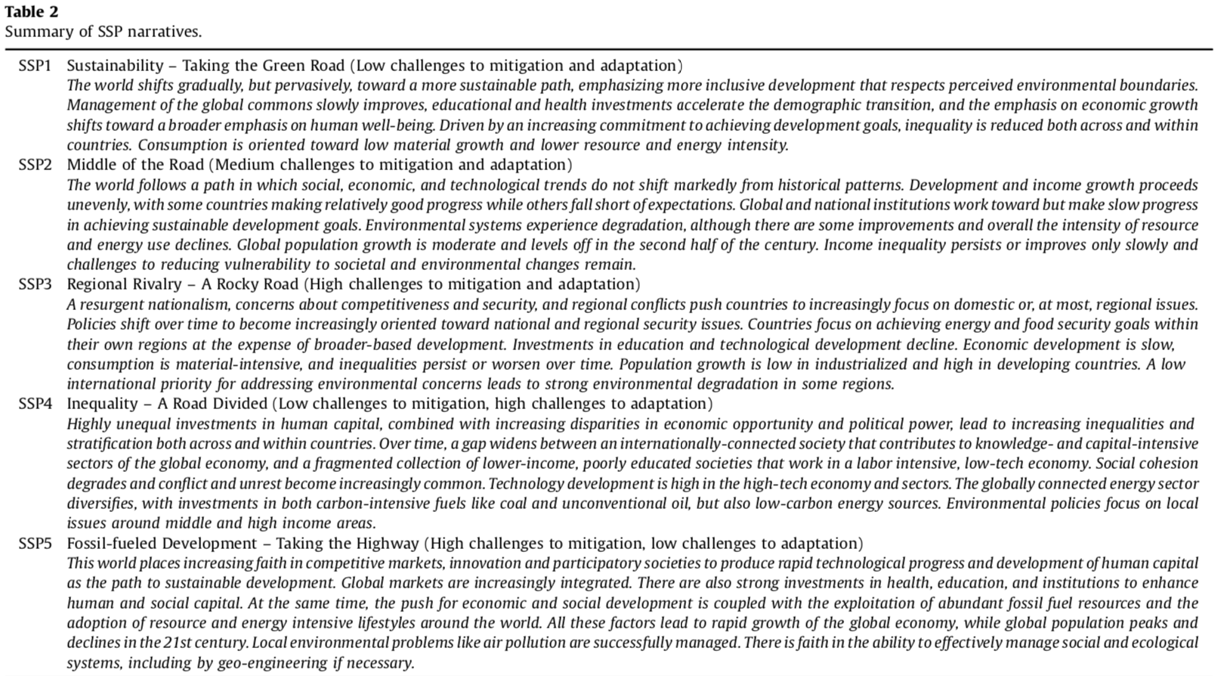

[The original peer-reviewed paper is posted on Canvas in the same directory as all class materials from Nov.-30, e.g., Files>MuenchowLectures>Lecture21_Climate>2017-Riahi.pdf.]

Part II Questions from Chapters 12, 14, and 15 and external sources.

Question 1 (10 points): The following is a list of “vocabulary” the mastery of which is important in learning the language of marine life and ecology. Provide a short explanation, or definition, that demonstrates that you have understood the concept in the context of this course. Do not copy definitions from Wikipedia, these will not earn you any credit (I will check).

a-primary production
primary production is the terrestrial activity of autotrophs in supplying the higher food chain levels with energy and structural building blocks from the process of photosynthesis that utilizes sunlight.

b-food chain
food chain is the efficient and systematic sequence of transferring matter and energy in the form of food from one organism to the next and the amount of energy decreases from the lowest level to the highest level.

c-trophic level
Tropic levels are the classifications of organisms based on their feeding behaviors in steps of nutritive series in an ecosystem.

d-countershading
countershading is the form of coloration that is concealing the upper body surfaces that are rather having darker pigmentation than the lower parts which are illuminated, thereby resulting to a more uniform body shade that helps in protecting the animals from predators.
e-epifauna
Epifauna is the composition of densities of aggregate animals that live on the surface of the bottom of the oceans, seas, lakes and are attached to other aquatic organisms.

f-symbiosis
Symbiosis is the evolved interaction between organisms of different species in a relationship that is beneficial to both organisms.
g-osmoregulation
Osmoregulation is the process of maintaining the osmotic balance across the membrane within the cells of plants and animals.

h-fundamental niche
Fundamental niche is the full range of environmental conditions that a viable population of species can occupy and use without any limiting factors present that constrains the population.

i- Supralittoral zone
Supralittoral zone is the area above the spring high tide line on coastlines or estuaries.

j-tube worms
Tube worms are marine invertebrates that are tube dwelling belonging to the annelid class Polychaeta.

Question 2: About iron fertilization (30 points) Read the article “Will Ocean Iron Fertilization Work?” posted in the Exam 4 folder on Canvas. Answer the following three questions. Make sure to pay attention to the specific word counts. List the number of words at the end of your paragraph.
a-While adding iron to the ocean seems simple, why is it so difficult to conduct iron fertilization experiments (100-150 words, 10 points)?
he typical method involves drizzling acidified iron sulfate into the ocean as a thin slurry, to reduce the amount that immediately sinks out of the sunlit surface waters where photosynthesis happens. adding the iron requires a 12-hour zigzagging cruise across a theoretical square of water whose boundaries shift constantly in the ocean currents. in the weeks of monitoring that follow, a ship typically spends 12 hours out of every day just mapping out the boundaries of the bloom. Blooms are hard to track because the added iron rapidly dilutes, sinks, and reacts with seawater, becoming virtually undetectable after a few days, Boyd said. Researchers add minute amounts of an inert tracer, sulfur hexafluoride (sF6), itself a potent green-house gas.
b-According to the article, what is meant with “location, location, location”? What is the best location and why (100-150 words, 10 points)?
Blooms depend crucially on location at two levels: the appropriate ocean region as well as the particular patch of water in that region chosen to receive the iron slurry. so far, iron fertilization has been contemplated mainly for ocean waters known as high-nutrient, low-chlorophyll (Hnlc) regions. These areas have high levels of other nutrients that plankton need to grow, including nitrate, phosphate, and silicic acid. Only iron is missing. Hnlc waters occur in the northern and equatorial Pacific and in the Southern Ocean, so iron addition ought to work in any of them.
c-Discuss whether or not, or to what extent, Fe fertilization works (100-150 words, 10 points).
The emerging picture is that iron fertilization does in principle work well enough to squirrel away carbon for at least a few decades possibly useful in the world’s efforts to solve its carbon emissions problem. although present yields seem low, improved methods could boost that number in two ways: by refining logistics to make blooms larger, and by increasing “export efficiency,” or the proportion of carbon that sinks from the surface into deeper waters, where it is less easily returned to the atmosphere. Thus Fe fertilization works and the main aim of reducing carbon dioxide from the atmosphere makes it the best option applicable.

Question 3 (10 points): “Build-a-Fish”:

- (5 points) Describe a fish that is adapted to life in a coral reef. Your description will include the general body shape of the fish (1 point), at least two types of fins (2 points), and two adaptions of your choosing that help it succeed in what it does (2 points). For full credit, your description must include a justification, or explanation, of the purpose of the particular shape, fins, and adaptations.
An example of a fish that is adapted to coral reef is the queen angelfish. Its body is flattened to fit in relatively confined spaces and to dart and change directions easily. It has pectoral and pelvic fins that enables its maneuverability. The fish brightly colored to camouflage with the environment and evade predators. It also has specialized teeth as an adaptation to feed on their primary food sources.

b) Sketch your fish and label all adaptations that you describe above. (Take a picture of your sketch and insert as a jpg) (5 points).

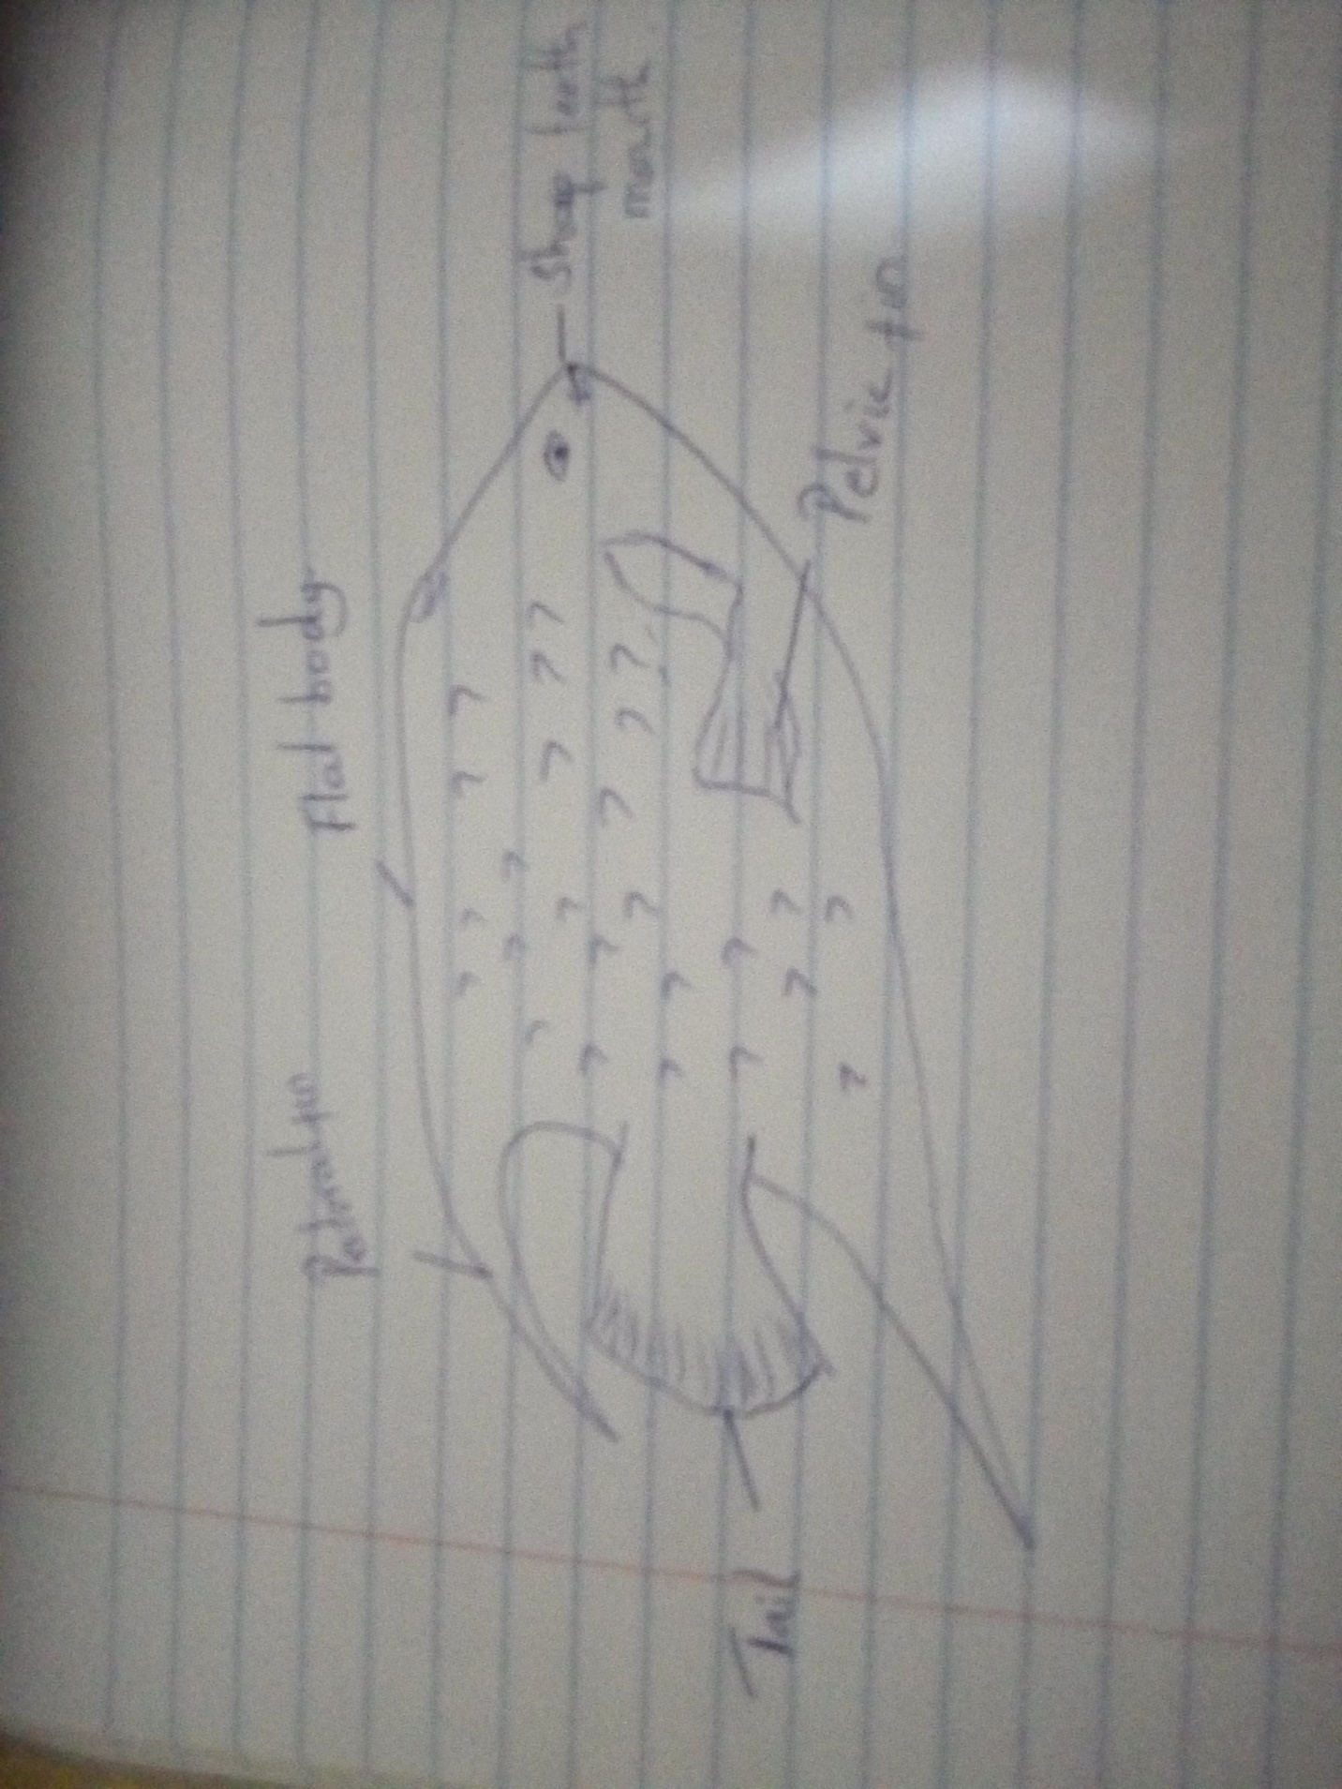

Question 4 (20 points). Watch the lecture “The Biggest Control Knob” by Richard Allen available via the link below and answer the following questions (note that the lecture is about 60 minutes long):
https://www.youtube.com/watch?v=3UVb--2-PBg

- According to Alley, what is the biggest control knob (1 point)? A single word answer will suffice.
The biggest control nob is Carbon dioxide that has been in influence of the earth’s climate since the ancient times.

- Pick one of the warm intervals in the geologic past that Alley describes and provide a brief summary (3-5 sentences, no more than 50-80 words) (5 points). For full credit, tell me which warm interval you picked (1 point), the approximate age of the event (1 point), and what appears to have happened (3 points).
One of the intervals he speaks about is the CO₂ Paleo barometers, where many others based on influence of CO₂ abundance on something else that is preserved in sedimentary record plus data-driven biogeochemical modelling. Systematic errors of different techniques largely independent so rely on cross-technique agreement.

- What is Alley’s analogy for CO₂ being important in climate (1 point) and explain how it works (8 point)?
His analogy states that CO₂ is important to climate since the beginning.

c) What question do you have for the speaker (5 points)? This question has to relate to his lecture. For full credit, the question has to be properly formulated. This means that your question has to refer to a specific part of the lecture. For example, you might ask “In your lecture you mentioned that xxx does yyy…, now I am wondering why/how/….” Or: “In your lecture you talked about xxx, zzz, and yyy, what do you think about why vvvv….?”

